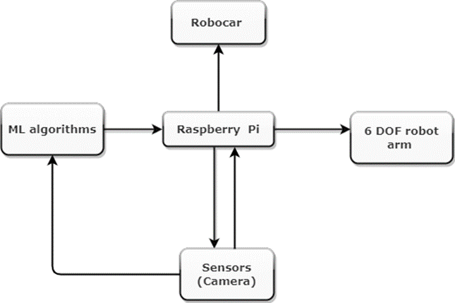

Raspberry pi:

Facilitates data processing and decision-making.

Facilitates wireless communication for real-time coordination.

6 DOF robot arm:

Boasts six degrees of freedom for precise and adaptable movements.

Executing actions based on commands from the computer vision software.

Sensor (camera and proximity):

Capture visual data for computer vision analysis.

Detect the proximity of obstacles to ensure safe navigation.

Robo-car:

Provides the mobility platform for Trashobot, allowing it to navigate various household terrains. Equipped with 4 DC motors and 4 wheels.

Computer vision software:

Employs algorithms to analyze visual data from cameras.

Identifies and classifies different types of trash in real-time.

